Transceiver pros QRP – MAS contest … 80m band only. OK1ICJ.

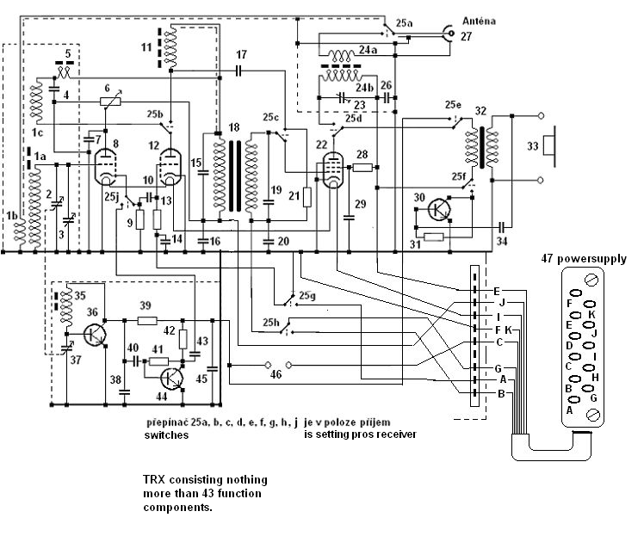
conponents: ٭( part do not count )

1 – hf transformator input RX 2 –(37) tuning dual capacitor 3 – capacitor RIG
4 – Cb 5 – coil hf filter 6 – potenciometer
7 – Cb 8 – el. tube ½ E88CC 9 – Rk
10 – Ck 11- coil 12 – el. tube ½ E88CC
13 – Rg 14 – Cb 15 – C lf filter
16 –Cb 17 – Ck 18 – transformator lf filter
19 – C lf filter 20 – Cb 21 – Rg
22 – el. tube E180F 23 – tuning capacitor PA 24 – hf transformator output PA
٭(25 – switches 9 x 2) 26 – Cb ٭(27 – connector antenna PL259)
28 – Rg2 29 – Cb 30 – transistor KC147
31 – Rb 32 – lf transformator output phones ٭(33 – headphones)
34 – Ck 35 – coil oscilator 36 – transistor KF173
37 – (2) tuning dual capacitor 38 – C colector 39 – Rl
40 – Ck 41 – Rb 42 – Rl
43 – Ck 44 – transistor KF508 45 – Cb
٭(46 – socket pros key) ٭(47 – power supply)

calculation: 47 minus ٭( 5 ) = 42 components

Jiří Cipra OK1ICJ.

